

A Mini Project Synopsis on
“Student AI Assistant”

Submitted
In partial fulfilment of the requirement for the V Semester of Bachelor of Technology in Computer Science and Engineering of the academic year 2020-21

Submitted By

Samarth D Valmiki R18CS364
Raghavendra A R18CS317
R Hemanth Kumar R18CS311
S Rohan R18CS336

Mini Project Group ID: F9
Section: F

Under the guidance of:

Prof. Shiva kumar R Naik

School of C & IT, REVA University

REVA UNIVERSITY
School of Computing and Information Technology
Bengaluru-560064
2020-21

ABSTRACT

Artificial intelligence technologies are beginning to be actively used in human life, this is facilitated by the appearance and wide dissemination of the Internet of Things (IoT). Autonomous devices are becoming smarter in their way to interact with both a human and themselves. New capacities lead to the creation of various systems for the integration of smart things into Social Networks of the Internet of Things. One of the relevant trends in artificial intelligence is the technology of recognizing the natural language of a human. New insights in this topic can lead to new means of natural human-machine interaction, in which the machine would learn how to understand human language, adjusting, and interacting in it. One of such tools is voice assistant, which can be integrated into many other intelligent systems. The base of the concept is based on probability theory like perceptron, naïve Bayes, k-mean Clustering, etc. The python modules which we are using are Pyaudio for recognition,pyttsx3 for voice samples, Date Time module to check date and time to remind something, NumPy to work with arrays and lists, pandas to work with structured data, requests for web scraping, TensorFlow to run machine learning algorithms, speech recognition for processing audio requests, OpenCV for screen automation, and basic python language functional requirements. For website users, we will develop using Html and CSS for front end and Flask(python library, javascript for backend, and MySQL for database queries and final deployment selenium for web testing and security purpose in which all these includes voice assistance and learning-related queries. For mobile or desktop applications we will mainly use kivy(python library) module, which will run in all the platforms like Windows, Linux, Android, etc. Since there is a performance issue with python language, c++ could be used to improve performance and integrate with python code.

INTRODUCTION
The term “AI” defines Automation of things helping people to solve the problems quickly. In this proposal we are making student job easier in understanding the concept or topic. This system will also make simple things automation like increasing volume while playing media, turn off the pc, sending mails, play songs, remember something, auto reply on messages, and many more. We are basically using python modules to solve all these problems, and we will also use basic machine learning algorithms.

Today the development of artificial intelligence (AI) systems that are able to organize a natural human-machine interaction (through voice, communication, gestures, facial expressions, etc.) are gaining in popularity. One of the most studied and popular was the direction of interaction, based on the understanding of the machine by the machine of the natural human language. It is no longer a human learns to communicate with a machine, but a machine learns to communicate with a human, exploring his actions, habits, behaviour and trying to become his personalized assistant.

The work on creating and improving such personalized assistants has been going on for a long time. These systems are constantly improving and improving, go beyond personal computers and have already firmly established themselves in various mobile devices and gadgets. One of the most popular voice assistants are Siri, from Apple, Amazon Echo, which responds to the name of Alex from Amazon, Cortana from Microsoft, Google Assistant from Google, and the recently appeared intelligent assistant under the name "AIVA".

Section I, II presents a brief introduction to the architecture and construction of voice assistants. Section III provides proposed plan of work. Section IV provides methodology of the work of a voice assistant AIVA. Section V describes the test results of the voice assistant. Section VI and VII describes the conclusion and future scope of an assistant using various artificial intelligent algorithms and gives a comparative evaluation of the learning ability of algorithms. The main goal of this work is to build a local voice assistant that does the work of human and the daily task that a human needed to do in daily life.

AIVA (2018) aimed at developing a voice-controlled personal assistant which is doing many things such as to search the Internet. It has some new features like posting comments on the social media websites such as Facebook, Twitter, etc. By just few simple commands. You can also know the weather around you and can get the climate conditions in your region. It can open and launch web-applications and the local storage of the user computer. Machine learning holds massive percentage in Automation service system with machine learning we can reduce time and give better services to the clients. Since we are also students we can understand the student problem better with understanding concepts and answer the application level Questions .So we taught that we can solve this problems with the help of our project called “student AI assistant” which will enables in learning from the concepts till the advanced level problem solving strategy .

LITERATURE SURVEY

METHODS:
  - Speech Recognition
    - The system uses Google’s online speech recognition system for converting speech input to text. The speech input Users can obtain texts from the special corpora organized on the computer network server at the information center from the microphone is temporarily stored in the system which is then sent to Google cloud for speech recognition. The equivalent text is then received and fed to the central processor.
  - Python Backend
    - The python backend gets the output from the speech recognition module and then identifies whether the command or the speech output is an API Call, Context Extraction, and System Call. The output is then sent back to the python backend to give the required output to the user.
  - API Calls
    - API stands for Application Programming Interface. An API is a software intermediary that allows two applications to talk to each other. In other words, an API is the messenger that delivers your request to the provider that you are requesting it from and then delivers the response back to you.
  - Context Extraction
    - Context extraction (CE) is the task of automatically extracting structured information from unstructured and/or semi-structured machine-readable documents. In most of the cases this activity concerns processing human language texts by means of natural language processing (NLP). Recent activities in multimedia document processing like automatic annotation and content extraction out of images/audio/video could be context extraction TEST RESULTS.
  - System Calls
    - In computing, a system call is the programmatic way in which a computer program requests a service from the kernel of the operating system it is executed on. This may include hardware-related services (for example, accessing a hard disk drive), creation and execution of new processes, and communication with integral kernel services such as process scheduling. System calls provide an essential interface between a process and the operating system.
  - Text-To-Speech
    - Text-to-Speech (TTS) refers to the ability of computers to read text aloud. A TTS Engine converts written text to a phonemic representation, then converts the phonemic representation to waveforms that can be output as sound. TTS engines with different languages, dialects and specialized vocabularies are available through third-party publishers.

Objectives

- The assistant will act as a learning platform for students on a particular topic with doubt solving and problem-solving included.
- At first, a student will use our AI voice assistant for a specific concept.
- After that, we will produce three options called full learning, overview learning, and quick learning.
- The Full learning option will provide links like:
  - YouTube lectures (which includes most of the video content for any concept).
  - Wikipedia link.
  - geeks for geeks/stack overflow links.
  - The last option would be to ask doubts (which would be satisfied by providing the link to post doubts in sites like geeks for geeks or stack overflow).
- The next option will be solving some problems related to that and make sure that we understood the concepts.
- Overview learning deals with only by giving lectures and notes for study.
- Quick learning only deals with only lectures or notes.

Our final goal is to make sure that the student will understand the concepts better and make better progress.

SYSTEM REQUIREMENTS

Software Requirements | Hardware Requirements
Flask, SQL, Html, CSS, JavaScript. | PC with Proper internet connection
Kivy, C++, Django, Selenium, pyttsx3, NLP, TensorFlow, Pandas, NumPy, OpenCV, etc. | None

Expected Implementation Method
The work started with analysing the audio commands given by the user through microphone. This can be anything like getting any information, operating computer’s internal files, etc.
Central Processor
Speech Recognition Module
Microphone
Audio Commands
Routines

Fig.2 Basic Workflow

This is an empirical qualitative study, based on reading above mentioned literature and testing their examples. Tests are made by programming according to books and online resources, with the explicit goal to find best practices and a more advanced understanding of Voice Assistant.

Fig.2 shows the workflow of the basic process of the voice assistant. Speech recognition is used to convert the speech input to text. This text is then fed to the central processor which determines the nature of the command and calls the relevant script for execution.
But the complexities do not stop there. Even with hundreds of hours of input, other factors can play a huge role in whether the software can understand you. Background noise can easily throw a speech recognition device off track. This is because it does not inherently could distinguish the ambient sounds it “hears” of a dog barking or a helicopter flying overhead, from your voice. Engineers must program that ability into the device; they conduct data collection of these ambient sounds and “tell” the device to filter them out. Another factor is the way humans naturally shift the pitch of their voice to accommodate for noisy environments; speech recognition systems can be sensitive to these pitch changes.

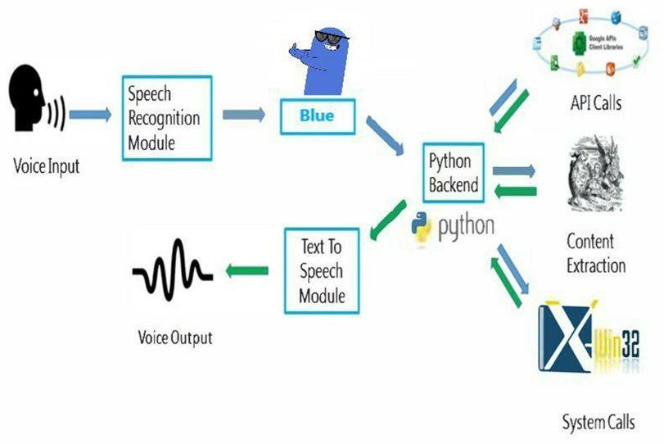
AIVA
Fig.3. Detailed Workflow

EXPECTED NEW APPLICATIONS

- Creates good working environment.
- Creates good user interface.
- Helps them do more things using voice input.
- Could increase the scope of this assistant to various applications by including more modules.
- The Assistant can be called with a custom name.
- Makes better learning usage.
- Gives a perfect Interface between free online learning and mastery.
- All in one learning kit.

CONCLUSION

The whole point of the project is to make an assistant application that would satisfy the student's urge to learn and provide all the necessary tools required to achieve mastery in any concept. The project also holds a motive to make the student understand how exciting the process of self-learning is. The very intention of this project would succeed if it can bring the thought of getting self-educated in a student.

REFERENCES

- G. Bohouta, V. Z. Këpuska, "Comparing Speech Recognition Systems (Microsoft API Google API And CMU Sphinx)", Int. Journal of Engineering Research and Application 2017, 2017.
- Artificial intelligence (AI), sometimes called machine intelligence. https://en.wikipedia.org/wiki/Artificial_intelligence
- B. Marr, The Amazing Ways Google Uses Deep Learning AI.
- Cortana Intelligence, Google Assistant, Apple Siri.
- Hill, J., Ford, W.R. and Farreras, I.G., 2015. Real conversations with artificial intelligence: A comparison between human– human online conversations and human–chatbot conversations. Computers in Human Behavior, 49, pp.245-250.
- K. Noda, H. Arie, Y. Suga, T. Ogata, Multimodal integration learning of robot behavior using deep neural networks, Elsevier: Robotics and Autonomous Systems, 2014.
- "CMUSphnix Basic concepts of speech - Speech Recognition process". http://cmusphinx.sourceforge.netlwiki/tutorialconcepts
- Huang, J., Zhou, M. and Yang, D., 2007, January. Extracting Chatbot Knowledge from Online Discussion Forums. In IJCAI(Vol. 7, pp. 423-428).
- Thakur, N., Hiwrale, A., Selote, S., Shinde, A. and Mahakalkar, N., Artificially Intelligent Chatbot.
- Mohasi, L. and Mashao, D., 2006. Text-to-Speech Technology in Human-Computer Interaction. In 5th Conference on Human Computer Interaction in Southern Africa, South Africa (CHISA 2006, ACM SIGHI) (pp. 79-84).
- Fryer, L.K. and Carpenter, R., 2006. Bots as language learning tools. Language Learning & Technology.

